EventGate Backend System Design
  - Architecture database design API specifications and system workflows
Prepared by Sayem Hasan
26 October 2026
EventGate manages the full journey from event discovery and limited ticket inventory to verified payments, QR admission and refunds. This design explains how the existing project protects stock, money and admission state while serving attendees, organizers and administrators.
The backend is a modular Express and TypeScript application using Prisma and PostgreSQL. A browser backend for frontend manages cookie sessions through Redis. Durable database jobs handle reservation expiry, payment verification, refunds and notifications. PostgreSQL remains the source of truth for inventory and financial outcomes.
Project references Existing EventGate application and backend source
EventGate application
EventGate backend repository
Open the completed ERD in Draw.io
Open the SDA workflow and architecture diagrams

Document map
Section | Content
1 | Project purpose target users eight core features and roles
2 | Backend architecture and responsibilities
3 | SDA workflow and transaction explanation
4 | Database ERD entity dictionary and relationships
5 | API conventions and complete operation catalogue
6 | Detailed request and response designs for ten APIs
7 | State transitions reliability security and validation checks

1 Project requirements
Project name EventGate
Target users People booking events in Bangladesh, organizers publishing and operating events, and administrators overseeing users, payments and operational exceptions.
Main purpose Offer a reliable event ticketing system where available stock cannot be oversold, payment is confirmed by the provider, each issued pass admits one attendee once, and refund requests remain traceable.

Eight core features
Feature | User value and backend responsibility
1 Identity and account management | Registration, password and Google sign in, session rotation, profile settings, verification and role enforcement.
2 Event discovery and personalization | Search and filter published events; read event facts and fresh availability; save events, choose preferences and request stock alerts. Optional AI assists discovery without modifying bookings.
3 Organizer event lifecycle | Create drafts, manage ticket tiers, check publication readiness, publish valid events and process cancellations.
4 Inventory reservation and order history | Reserve 1 to 10 tickets in one tier for 15 minutes; use authoritative stock checks, idempotency and price snapshots.
5 Verified checkout and payment history | Create hosted SSLCommerz checkout, record attempts and callbacks, verify captures and reconcile uncertain outcomes.
6 Private tickets and QR admission | Issue tickets only after verified fulfillment; protect QR retrieval; validate event, time window and unused admission status.
7 Refunds and event cancellation recovery | Check attendee eligibility, record administrator review, process provider refunds and retain an audit trail.
8 Notifications reports and administration | Deliver account and event updates; present sales and attendance reports; manage accounts and investigate recovery jobs.

User roles and authorization
Role | Allowed actions | Scope restriction
Visitor | Browse published events and available tiers; register or sign in; use public discovery assistance. | No private orders tickets reports or organizer drafts.
ATTENDEE | Manage own profile, save events, join alerts, reserve and pay, view private tickets and request refunds. | Every resource request is constrained to the authenticated attendee.
ORGANIZER | Create and manage events and tiers, publish, cancel, inspect event orders and reports, and check tickets in. | Must own the event. Organizer role alone does not grant access to another organizer event.
ADMIN | Manage user roles and status, inspect platform records, cancel events with an audit reason, review refunds and retry eligible recovery work. | Sensitive actions are audited; administrator access does not make an unverified payment successful.

Visitor is an unauthenticated actor rather than a stored UserRole. Public self registration creates ATTENDEE accounts; callers cannot assign themselves privileged roles.

2 Basic backend architecture
The application uses a modular monolith so related business rules can share explicit database transactions. Domain modules separate authentication, events, ticket tiers, orders, payments, tickets, refunds, discovery, notifications and reporting. The service layer uses Prisma directly; a separate repository layer is not required to explain the existing architecture.
Layer | Responsibility and boundaries
Client | Collect user intent and render confirmed state. Client side validation improves usability but does not authorize operations or establish stock, payment or admission outcomes.
Browser BFF | Receive same origin browser requests; resolve an HttpOnly session cookie in Redis; attach encrypted server held tokens to API calls; enforce origin and CSRF checks on mutations. Direct API clients use Bearer access tokens.
Express entry and middleware | Assign request IDs, parse bounded payloads, apply security headers, CORS and rate limits. Authenticate JWTs against current user status and token version; authorize allowed roles.
Routes and schema validation | Match method and path; run Zod validation for path parameters, query strings and request bodies before invoking a controller.
Controllers | Extract validated input and trusted identity, invoke services, and select the documented HTTP status and response envelope. Keep business decisions in services.
Domain services | Enforce resource ownership, sales and refund windows, lifecycle rules, idempotency and financial invariants. Choose row locking and transaction boundaries.
Prisma ORM and PostgreSQL | Execute queries and transactions; enforce PKs, FKs, unique keys and persisted state. PostgreSQL owns inventory, payments, passes and audit records.
Jobs and integrations | Process leased durable jobs for expiry, provider verification, refunds and notifications. Provider network calls occur outside database transactions; validated results are applied in new transactions.
Central error handler | Translate expected domain failures into safe JSON errors, log unexpected faults with a request ID, and prevent credentials or provider diagnostics from leaking.

Redis is used for browser session infrastructure and optional public or AI caching. A cache is never used as the final authority for reservation inventory, money, refund eligibility or admission. If optional discovery caching fails, the API can read PostgreSQL; failure of required session storage prevents authentication from being assumed successful.

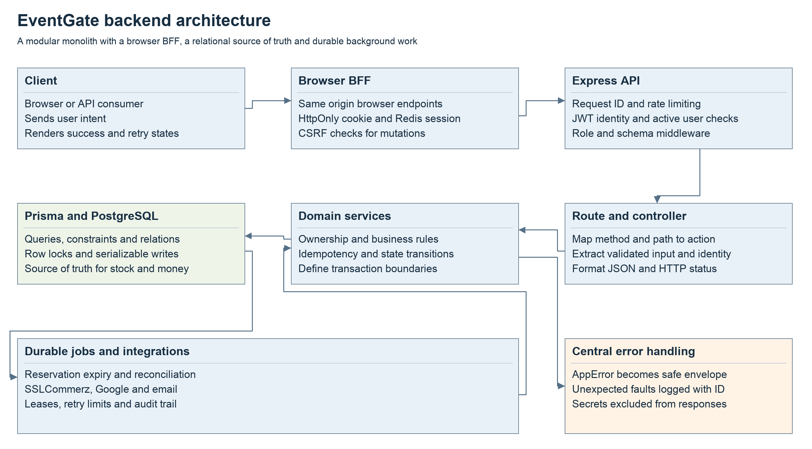
Figure 1 Backend layers and supporting services. A direct API consumer may call Express without the browser BFF.

3 SDA workflow

Major feature Reserve tickets and confirm payment
The workflow starts when an attendee reserves ticket inventory and ends when a verified payment results in issued passes. The reservation response is intentionally separate from the later payment outcome.
1. Client request. The attendee selects a tier and quantity. The browser BFF sends POST /api/v1/orders with a Bearer token and a stable Idempotency-Key. No client submitted price is trusted.
2. Route and middleware. The API assigns a request ID, applies a rate limit, authenticates the active attendee, checks the required role, and validates the UUID and integer quantity from 1 to 10.
3. Controller. The order controller reads the idempotency header and forwards the validated body and authenticated attendee ID to the order service.
4. Business validation. The service checks the stored idempotency key and request hash, locks the related event and tier, and rechecks event publication, sales pause, sales window and available stock.
5. Database transaction. The service reserves inventory, creates the order with price snapshots and an expiry 15 minutes later, and records idempotency and audit state. The transaction commits together or rolls back together. Serialization conflicts have bounded retries.
6. API response. After a commit, the controller returns HTTP 201 and the confirmed order. Invalid input receives 400; unauthenticated access 401; disallowed roles 403; hidden or absent resources 404; unavailable stock or conflicting state 409.
7. Checkout request. The attendee sends POST /payments/orders/:orderId/checkout. The service checks ownership, active reservation and checkout profile, persists a payment attempt, then calls SSLCommerz outside the transaction.
8. Provider callback. A success, failure, cancellation or IPN payload is persisted with a deduplication key. Browser redirect parameters are not trusted as payment proof. A worker queries the provider validation API and compares transaction identity, amount and currency.
9. Verified fulfillment. A new database transaction converts reserved inventory to sold inventory, marks the canonical purchase paid and issues one ticket for each purchased unit. Replayed callbacks do not issue additional passes.
10. Readback and recovery. The attendee reads the authoritative order or attempt status and retrieves private QR passes when eligible. Expired reservations release stock. Late captures and ambiguous outcomes are reconciled, refunded or flagged for investigation rather than silently fulfilled.

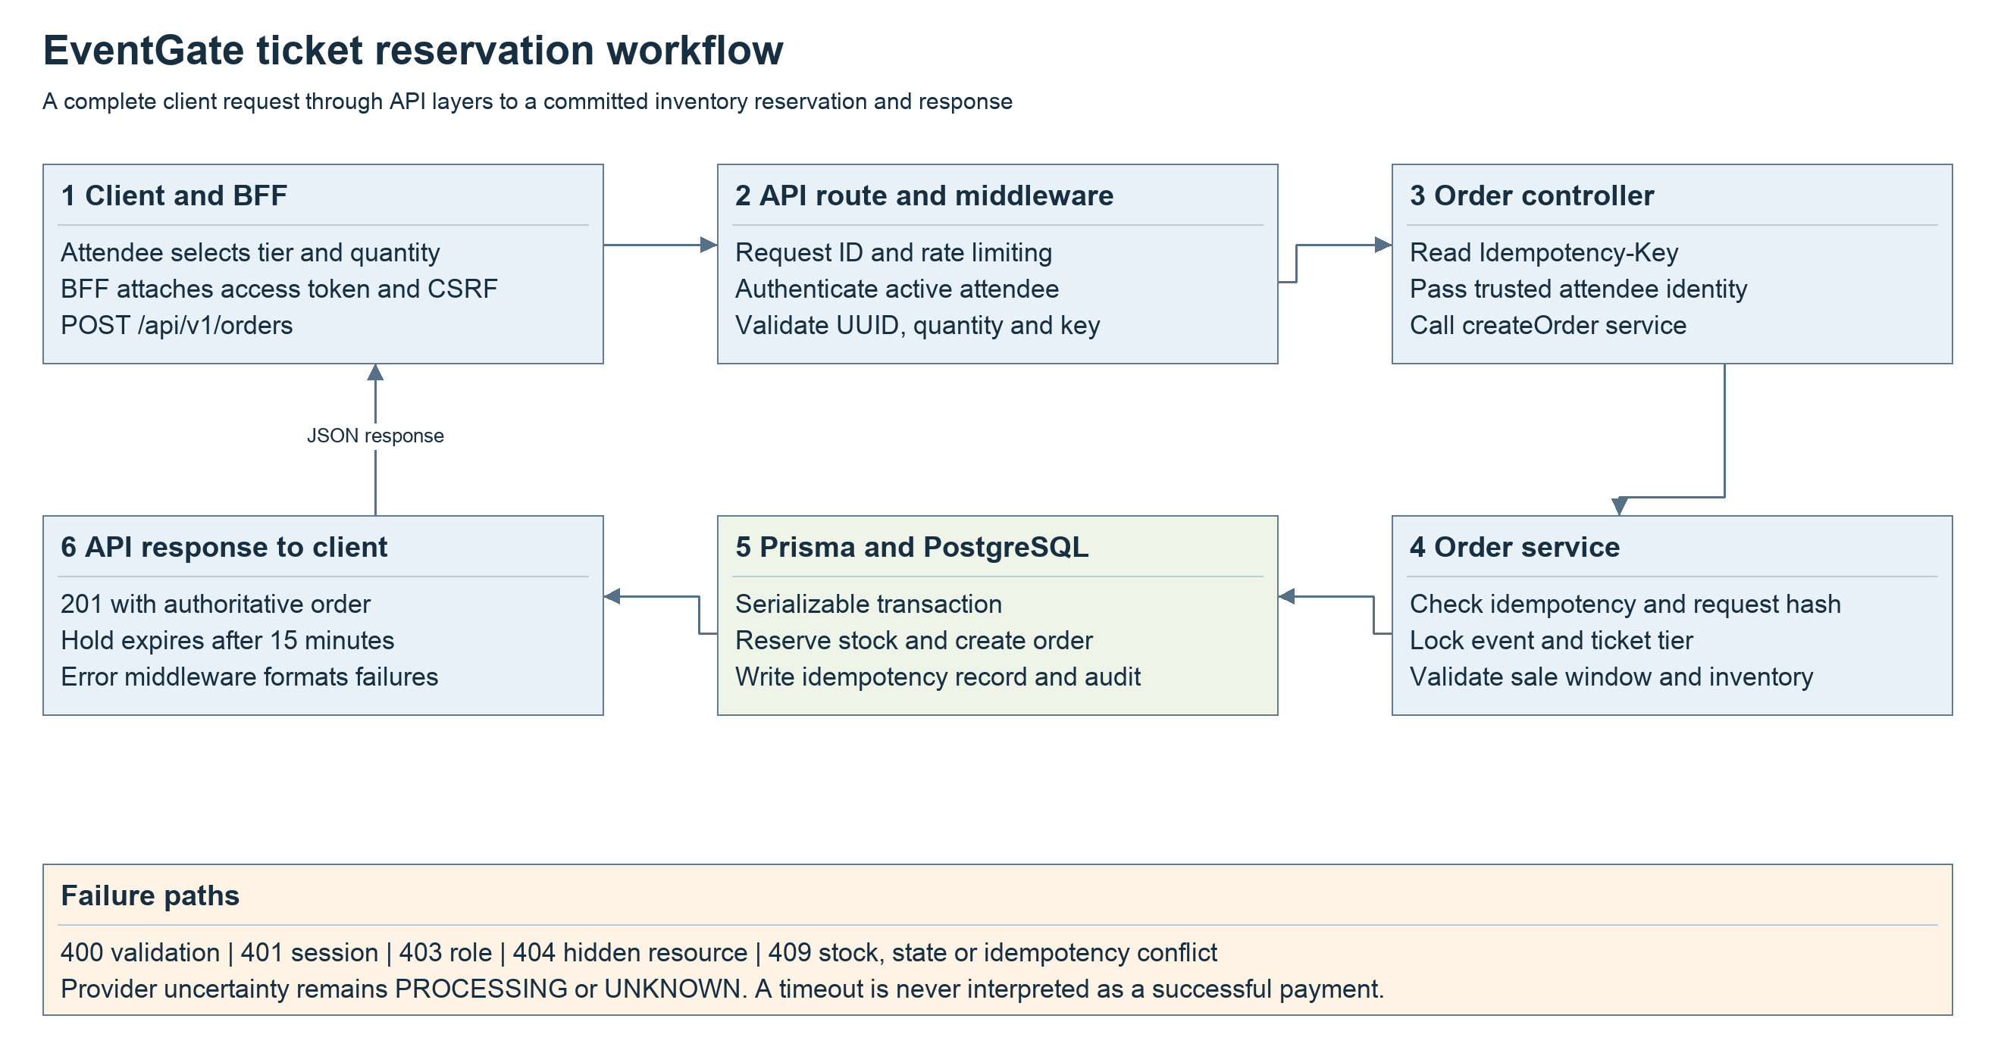
Figure 2 Ticket reservation with atomic inventory updates and safe error responses. Payment verification follows as described in steps 7 to 10.

4 Database design
PostgreSQL stores 23 entities. The ERD is divided into four named Draw.io views for readability. Tables repeated between views are references to the same physical table. The views show important fields; the dictionary and relationship ledger below record keys and cross view dependencies.
ERD share link
Notation PK means primary key, FK means enforced foreign key, UQ means unique, and ? means nullable. Most identifiers are UUIDs. MaintenanceState.id is a text key. A parent with 1 to 0..N children is a one to many association. A unique child FK limits it to zero or one child per parent. Nullable FKs mean a child may have no parent for that association.

Relationships and integrity rules
- One to many: an organizer User owns Events; an Event contains TicketTiers; an attendee User places Orders; an Order has PaymentAttempts and Tickets; a PaymentAttempt receives PaymentEvents.
- One to one where applicable: NotificationPreference.userId and EventPreference.userId are both PK and FK, so a User has zero or one row of each. Order.fulfilledPaymentAttemptId is nullable and unique, so a purchase selects at most one canonical attempt, and an attempt fulfills at most one order.
- Many to many: SavedEvent joins User and Event, unique on userId plus eventId. WaitlistEntry joins User and TicketTier, unique on userId plus ticketTierId. Orders also capture repeat purchase relationships rather than acting as a unique event membership.
- A ticket has a unique QR token and a unique orderId plus sequence. A payment attempt has a unique merchant transaction identifier and unique provider transaction fields when present. A callback event has a unique providerEventKey.
- Financial and ticket relationships generally use restrictive deletes to preserve history. PaymentEvent.paymentAttemptId uses SET NULL; EventPreference uses CASCADE on user deletion. Event and tier removal uses lifecycle rules and soft deletion where needed.
- Cross record rules such as a ticket tier belonging to the order event and the fulfillment attempt belonging to the order are enforced in services and transactions. A simple FK alone does not prove these business relationships.
- Scalar fields such as AuditLog.entityId, IdempotencyRecord.resourceId, PaymentEvent.capturedPaymentAttemptId and RefundActivity.actorId are not drawn as enforced FKs when the Prisma schema declares no relation.

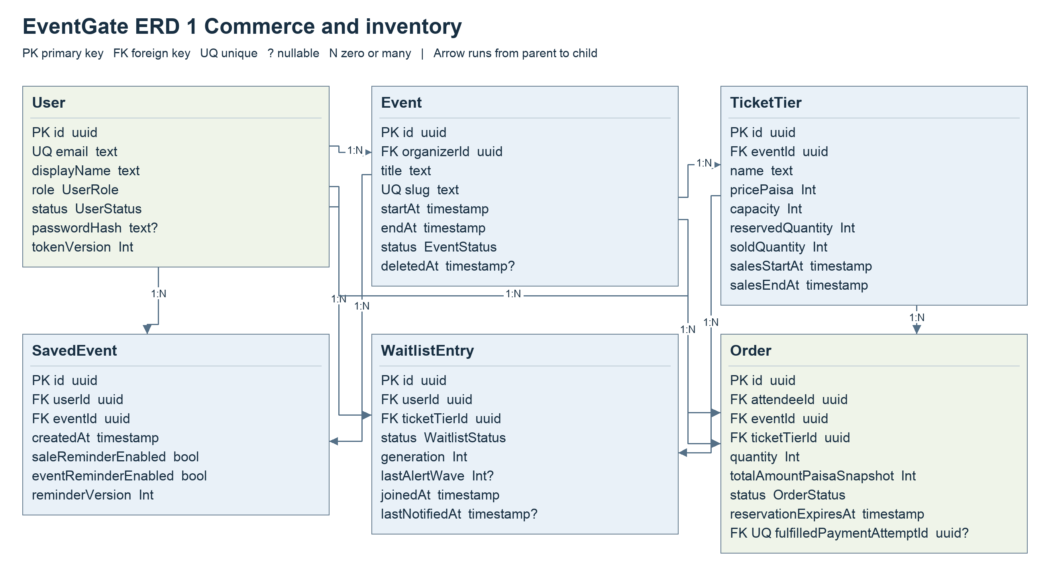
Figure 3 Commerce inventory and many to many memberships. Refer to the foreign key ledger for associations that span views.

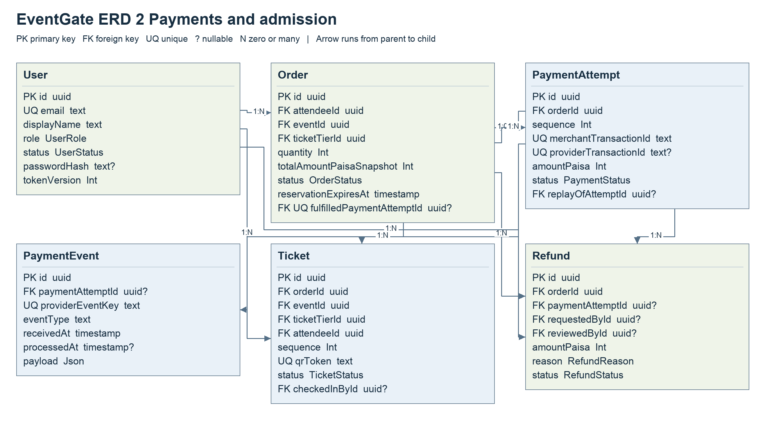
Figure 4 Payments admission and canonical purchase fulfillment. Refer to the foreign key ledger for associations that span views.

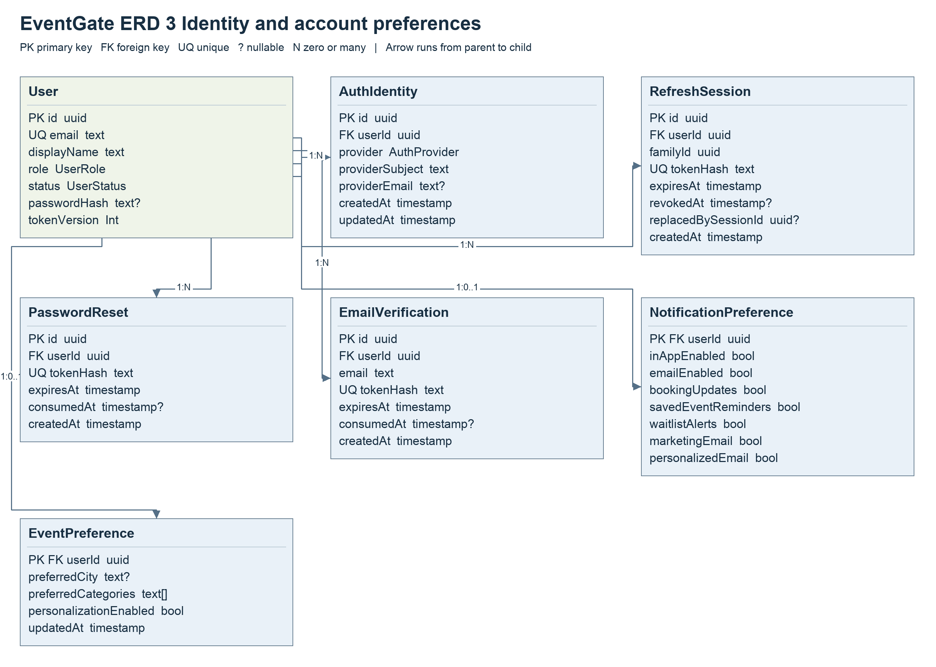
Figure 5 Identity recovery and one to one preferences. Refer to the foreign key ledger for associations that span views.

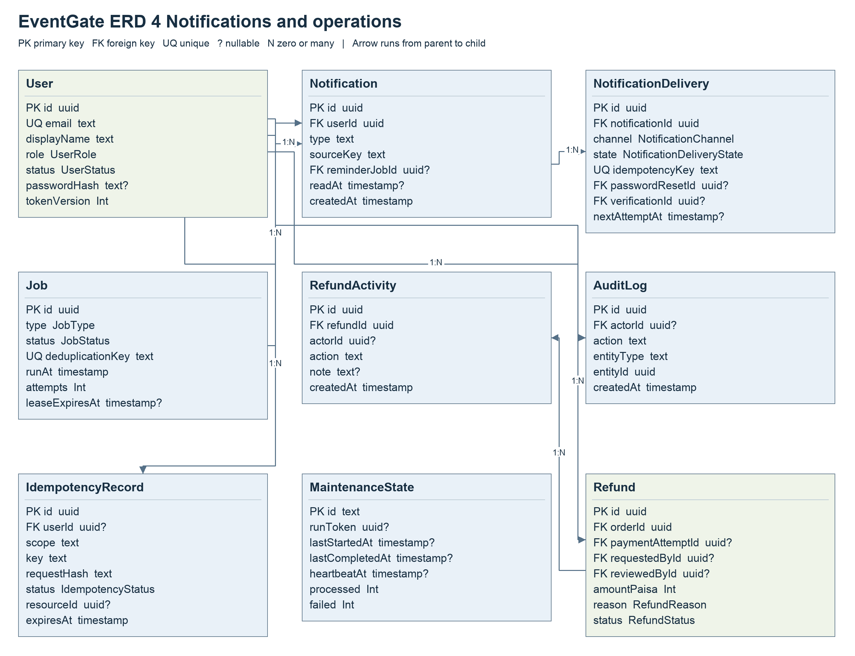
Figure 6 Notifications jobs and audit operations. Refer to the foreign key ledger for associations that span views.

Entity dictionary
Entity | PK | Enforced FK fields | Purpose and important unique constraints
EventPreference | userId | userId | One user personalization settings record.
User | id | None | Identity contact details role active status and credential version. Unique: email.
Notification | id | reminderJobId, userId | In app message and source deduplication key. Unique: userId+sourceKey.
NotificationPreference | userId | userId | One user notification settings record.
EmailVerification | id | userId | Hashed single use email verification token and expiry. Unique: tokenHash.
NotificationDelivery | id | notificationId, passwordResetId, verificationId | Per channel message delivery retry and provider state. Unique: notificationId+channel, idempotencyKey.
AuthIdentity | id | userId | External identity provider subject linked to a user. Unique: provider+providerSubject.
RefreshSession | id | userId | Hashed refresh token session family and revocation state. Unique: tokenHash.
Event | id | organizerId | Organizer owned event facts and publication lifecycle. Unique: slug.
SavedEvent | id | userId, eventId | User event membership with reminder settings. Unique: userId+eventId.
TicketTier | id | eventId | Priced inventory and sale window for an event. Unique: eventId+name.
WaitlistEntry | id | userId, ticketTierId | User tier stock alert membership and notification generation. Unique: userId+ticketTierId.
Order | id | attendeeId, eventId, ticketTierId, fulfilledPaymentAttemptId | Attendee reservation with immutable event tier and price snapshots. Unique: fulfilledPaymentAttemptId.
PaymentAttempt | id | orderId, replayOfAttemptId | Provider checkout attempt with sequence and capture identity. Unique: orderId+sequence, merchantTransactionId, providerSessionKey, providerTransactionId, providerValidationId.
PaymentEvent | id | paymentAttemptId | Deduplicated provider callback receipt and processing state. Unique: providerEventKey.
Ticket | id | orderId, eventId, ticketTierId, attendeeId, checkedInById | One admission pass per purchased unit with a unique opaque token. Unique: orderId+sequence, qrToken.
Refund | id | orderId, paymentAttemptId, requestedById, reviewedById | Provider linked refund request review and settlement lifecycle. Unique: paymentAttemptId+reason, idempotencyKey, providerRefundId.
RefundActivity | id | refundId | Append only history of refund actions.
AuditLog | id | actorId | Actor and entity history for sensitive business operations.
IdempotencyRecord | id | userId | Request hash and remembered command outcome per scope and key. Unique: scope+key.
Job | id | None | Durable asynchronous work with run time lease and retry limits. Unique: deduplicationKey.
MaintenanceState | id | None | Coordinator heartbeat and maintenance run summary.
PasswordReset | id | userId | Hashed single use password recovery token and expiry. Unique: tokenHash.

Complete foreign key ledger
Child FK | Referenced PK | Cardinality
EventPreference.userId | User.id | 1 parent per child; 0..1 children per parent
Notification.reminderJobId | Job.id | 0..1 parent per child; 0..N children per parent
Notification.userId | User.id | 1 parent per child; 0..N children per parent
NotificationPreference.userId | User.id | 1 parent per child; 0..1 children per parent
EmailVerification.userId | User.id | 1 parent per child; 0..N children per parent
NotificationDelivery.notificationId | Notification.id | 1 parent per child; 0..N children per parent
NotificationDelivery.passwordResetId | PasswordReset.id | 0..1 parent per child; 0..N children per parent
NotificationDelivery.verificationId | EmailVerification.id | 0..1 parent per child; 0..N children per parent
AuthIdentity.userId | User.id | 1 parent per child; 0..N children per parent
RefreshSession.userId | User.id | 1 parent per child; 0..N children per parent
Event.organizerId | User.id | 1 parent per child; 0..N children per parent
SavedEvent.userId | User.id | 1 parent per child; 0..N children per parent
SavedEvent.eventId | Event.id | 1 parent per child; 0..N children per parent
TicketTier.eventId | Event.id | 1 parent per child; 0..N children per parent
WaitlistEntry.userId | User.id | 1 parent per child; 0..N children per parent
WaitlistEntry.ticketTierId | TicketTier.id | 1 parent per child; 0..N children per parent
Order.attendeeId | User.id | 1 parent per child; 0..N children per parent
Order.eventId | Event.id | 1 parent per child; 0..N children per parent
Order.ticketTierId | TicketTier.id | 1 parent per child; 0..N children per parent
Order.fulfilledPaymentAttemptId | PaymentAttempt.id | 0..1 parent per child; 0..1 children per parent
PaymentAttempt.orderId | Order.id | 1 parent per child; 0..N children per parent
PaymentAttempt.replayOfAttemptId | PaymentAttempt.id | 0..1 parent per child; 0..N children per parent
PaymentEvent.paymentAttemptId | PaymentAttempt.id | 0..1 parent per child; 0..N children per parent
Ticket.orderId | Order.id | 1 parent per child; 0..N children per parent
Ticket.eventId | Event.id | 1 parent per child; 0..N children per parent
Ticket.ticketTierId | TicketTier.id | 1 parent per child; 0..N children per parent
Ticket.attendeeId | User.id | 1 parent per child; 0..N children per parent
Ticket.checkedInById | User.id | 0..1 parent per child; 0..N children per parent
Refund.orderId | Order.id | 1 parent per child; 0..N children per parent
Refund.paymentAttemptId | PaymentAttempt.id | 0..1 parent per child; 0..N children per parent
Refund.requestedById | User.id | 0..1 parent per child; 0..N children per parent
Refund.reviewedById | User.id | 0..1 parent per child; 0..N children per parent
RefundActivity.refundId | Refund.id | 1 parent per child; 0..N children per parent
AuditLog.actorId | User.id | 0..1 parent per child; 0..N children per parent
IdempotencyRecord.userId | User.id | 0..1 parent per child; 0..N children per parent
PasswordReset.userId | User.id | 1 parent per child; 0..N children per parent

Storage and indexing decisions
All amounts are integer paisa with BDT currency. Store timestamps in UTC using timezone aware columns and present event times in Asia/Dhaka. Preserve order snapshots so later event or tier edits do not rewrite purchase history. Audit metadata and provider payloads must be redacted before leaving authorized operational views.
Indexes follow access paths: Event organizer plus lifecycle and start time; Order attendee plus created time, event plus status, and status plus reservation expiry; Ticket event plus status and check in time; User role plus status; Job status plus runAt and lease expiry; and notification user plus readAt or createdAt. Unique keys provide the final duplicate barrier in addition to application checks.

5 API design conventions
Base path /api/v1. The catalogue below lists paths relative to that base.
Authentication Protected API requests use Authorization: Bearer <accessToken>. Authentication validates the current account and token version. Role checks are followed by ownership checks. Browser clients use the BFF session cookie and a CSRF header on mutations; JWTs are not kept in browser local storage.
Payloads Use application/json except provider callbacks, which accept bounded form encoded bodies. UUID path parameters are required where indicated by names such as eventId or orderId. Reject unknown fields in strict command schemas.
Idempotency POST /orders and POST /payments/orders/:orderId/checkout require Idempotency-Key with 1 to 255 characters. Retry the same key and same command after a network failure. Reusing the key for different input returns a conflict. Financial recovery endpoints do not manufacture successful provider outcomes.
Pagination List operations return data plus meta containing page, limit, total and totalPages. Common defaults are page 1 and limit 20 with maximum 100; endpoints may choose their own defaults. Public discovery supports search, city, category, date, sort and budget filters. Dates use ISO 8601 values.
Response rules Success uses success, message and data. Errors use success false, message and an errors array with code, message and optional field. A request ID header supports diagnosis. Examples below contain illustrative UUIDs and values and show essential fields rather than every optional server projection.
{
"success": true,
"message": "Example response",
"data": {
"id": "44444444-4444-4444-8444-444444444444",
"status": "PENDING_PAYMENT"
}
}
{
"success": false,
"message": "Validation failed",
"errors": [
{
"code": "INVALID_VALUE",
"message": "Quantity must be an integer between 1 and 10.",
"field": "body.quantity"
}
]
}
Status | Meaning
200 or 201 | Confirmed read or synchronous command; 201 creates a resource.
202 | Accepted or pending verification; it does not confirm payment or refund settlement.
400 | Invalid JSON schema field parameters or required command headers.
401 or 403 | Missing invalid or revoked authentication; insufficient role or inactive account.
404 | Missing resource or a resource concealed by ownership rules.
409 | Conflicting stock lifecycle idempotency or refund eligibility.
413 or 429 | Payload limit or rate limit exceeded.
500 or 503 | Unexpected server failure or an unavailable dependency.

Provider IPN acknowledgement is plain text OK. Browser payment callbacks return HTTP 303 to the application; neither response is proof of settlement. Check in business outcomes can use HTTP 200 with a resultCode such as ACCEPTED or ALREADY_CHECKED_IN, so the client must inspect the resultCode.

Complete API operation catalogue
All paths below use /api/v1. Bearer requires a current active user. Ownership restrictions are enforced in services as well as role middleware. Public AI and demo endpoints are configuration dependent. The catalogue covers all 109 API route operations in the design basis.

Administration and operations
Method | Endpoint | Purpose | Auth | Role or scope
GET | /admin/events | Read events | Bearer | ADMIN
GET | /admin/events/:eventId | Read events | Bearer | ADMIN
POST | /admin/events/:eventId/cancel | Cancel the reservation or event | Bearer | ADMIN
GET | /admin/orders/:orderId | Read orders | Bearer | ADMIN
GET | /admin/payments | Read payments | Bearer | ADMIN
GET | /admin/payments/:attemptId | Read payments | Bearer | ADMIN
POST | /admin/payments/:attemptId/reconcile | Schedule provider verification | Bearer | ADMIN
GET | /admin/refunds | Read refunds | Bearer | ADMIN
GET | /admin/refunds/:refundId | Read refunds | Bearer | ADMIN
PATCH | /admin/refunds/:refundId | Update refunds | Bearer | ADMIN
POST | /admin/refunds/:refundId/reconcile | Schedule provider verification | Bearer | ADMIN
POST | /admin/refunds/:refundId/retry | Queue a controlled recovery retry | Bearer | ADMIN
GET | /admin/reports/audit-logs | Read reports/audit logs | Bearer | ADMIN
GET | /admin/reports/audit-logs/:logId | Read reports/audit logs | Bearer | ADMIN
GET | /admin/reports/jobs | Read reports/jobs | Bearer | ADMIN
POST | /admin/reports/jobs/:jobId/retry | Queue a controlled recovery retry | Bearer | ADMIN
GET | /admin/reports/maintenance | Read maintenance status | Bearer | ADMIN
GET | /admin/reports/notification-deliveries | Read reports/notification deliveries | Bearer | ADMIN
GET | /admin/reports/operations | Read operational incidents | Bearer | ADMIN
GET | /admin/reports/statistics | Read aggregate statistics | Bearer | ADMIN
GET | /admin/reports/summary/:panel | Read reports/summary | Bearer | ADMIN
GET | /admin/users | Read users | Bearer | ADMIN
DELETE | /admin/users/:userId | Remove users | Bearer | ADMIN
GET | /admin/users/:userId | Read users | Bearer | ADMIN
PATCH | /admin/users/:userId/role | Change a user role | Bearer | ADMIN
PATCH | /admin/users/:userId/status | Change user account status | Bearer | ADMIN

Public discovery and assistance
Method | Endpoint | Purpose | Auth | Role or scope
POST | /ai/ask | Answer a question using public event facts | No | Public
GET | /ai/config | Read optional feature availability | No | Public
POST | /ai/search | Interpret a natural language event search | No | Public
GET | /events | Search and paginate published events | No | Public
GET | /events/:slug | Read events | No | Public
GET | /events/:slug/availability | Read current reservable inventory | No | Public
GET | /events/facets | Read discovery cities and categories | No | Public
GET | /health/live | Read process liveness | No | Public
GET | /health/ready | Read database readiness | No | Public

Authentication and account
Method | Endpoint | Purpose | Auth | Role or scope
POST | /auth/demo | Start a restricted shared demo session | No | Attendee or organizer demo only when enabled
POST | /auth/google | Sign in with verified Google identity | No | Public
GET | /auth/google/config | Read Google sign in availability | No | Public
POST | /auth/google/link | Link Google identity to own account | Bearer | Any active user; link own identity
POST | /auth/login | Create an authenticated session | No | Public
POST | /auth/logout | Revoke a refresh session | Refresh token | Token owner; not access JWT
POST | /auth/refresh | Rotate refresh token and access token | Refresh token | Token owner; not access JWT
POST | /auth/register | Register an attendee account | No | Public
POST | /auth/request-password-reset | Request account recovery email | No | Public
POST | /auth/reset-password | Reset password with a single use token | No | Public
GET | /users/me | Read users/me | Bearer | Active user own account
PATCH | /users/me | Update users/me | Bearer | Active user own account
POST | /users/me/email-verification | Request email verification | Bearer | Active user own account
POST | /users/me/email-verification/confirm | Confirm email verification token | Bearer | Active user own account
GET | /users/me/event-preferences | Read event preferences | Bearer | ATTENDEE own resources
PATCH | /users/me/event-preferences | Update event preferences | Bearer | ATTENDEE own resources
GET | /users/me/identity | Read current authenticated identity | Bearer | Active user own account
GET | /users/me/notification-preferences | Read notification preferences | Bearer | Active user own account
PATCH | /users/me/notification-preferences | Update notification preferences | Bearer | Active user own account
GET | /users/me/overview | Read role specific dashboard summary | Bearer | ATTENDEE own resources
POST | /users/me/password | Change password and revoke sessions | Bearer | Active user own account
GET | /users/me/waitlists | Read waitlists | Bearer | ATTENDEE own resources

Attendee purchases tickets and engagement
Method | Endpoint | Purpose | Auth | Role or scope
DELETE | /events/:eventId/ticket-tiers/:tierId/waitlist | Leave a stock alert | Bearer | ATTENDEE; own membership
GET | /events/:eventId/ticket-tiers/:tierId/waitlist | Read own stock alert membership | Bearer | ATTENDEE; own membership
PUT | /events/:eventId/ticket-tiers/:tierId/waitlist | Join a stock alert without reserving stock | Bearer | ATTENDEE; own membership
GET | /events/recommended | Read personalized published event suggestions | Bearer | ATTENDEE own resources
GET | /notifications | Read notifications | Bearer | Active user own account
PATCH | /notifications/:id/read | Mark one notification read | Bearer | Active user own account
POST | /notifications/read-all | Mark own notifications as read | Bearer | Active user own account
GET | /notifications/unread-count | Read unread notification count | Bearer | Active user own account
GET | /orders | Read orders | Bearer | ATTENDEE own resources
POST | /orders | Reserve inventory and create an order | Bearer | ATTENDEE own resources
GET | /orders/:orderId | Read orders | Bearer | ATTENDEE own resources
POST | /orders/:orderId/cancel | Cancel the reservation or event | Bearer | ATTENDEE own resources
POST | /orders/:orderId/refund-requests | Create orders/refund requests | Bearer | ATTENDEE own resources
GET | /payments/attempts/:attemptId | Read payments/attempts | Bearer | ATTENDEE own resources
GET | /payments/orders/:orderId/attempts | Read payments/orders/attempts | Bearer | ATTENDEE own resources
POST | /payments/orders/:orderId/checkout | Create or recover hosted checkout | Bearer | ATTENDEE own resources
POST | /payments/sslcommerz/cancel | Persist CANCEL callback and schedule verification | Provider validation | SSLCommerz callback; not a user JWT
POST | /payments/sslcommerz/fail | Persist FAIL callback and schedule verification | Provider validation | SSLCommerz callback; not a user JWT
POST | /payments/sslcommerz/ipn | Persist IPN callback and schedule verification | Provider validation | SSLCommerz callback; not a user JWT
POST | /payments/sslcommerz/success | Persist SUCCESS callback and schedule verification | Provider validation | SSLCommerz callback; not a user JWT
GET | /refund-requests | Read refund requests | Bearer | ATTENDEE own resources
GET | /refund-requests/:refundId | Read refund requests | Bearer | ATTENDEE own resources
GET | /saved-events | Read saved events | Bearer | ATTENDEE own resources
DELETE | /saved-events/:eventId | Remove saved events | Bearer | ATTENDEE own resources
GET | /saved-events/:eventId | Read saved events | Bearer | ATTENDEE own resources
PUT | /saved-events/:eventId | Join or save saved events | Bearer | ATTENDEE own resources
GET | /saved-events/memberships | Batch saved event membership reads | Bearer | ATTENDEE own resources
GET | /tickets | Read tickets | Bearer | ATTENDEE own resources
GET | /tickets/:ticketId | Read tickets | Bearer | ATTENDEE own resources
GET | /tickets/:ticketId/qr | Read private QR image | Bearer | ATTENDEE own resources
GET | /tickets/bookings | List complete purchased booking groups | Bearer | ATTENDEE own resources

Organizer events and reports
Method | Endpoint | Purpose | Auth | Role or scope
GET | /organizer/events | Read events | Bearer | ORGANIZER owner or ADMIN
POST | /organizer/events | Create events | Bearer | ORGANIZER owner or ADMIN
DELETE | /organizer/events/:eventId | Remove events | Bearer | ORGANIZER owner or ADMIN
GET | /organizer/events/:eventId | Read events | Bearer | ORGANIZER owner or ADMIN
PATCH | /organizer/events/:eventId | Update events | Bearer | ORGANIZER owner or ADMIN
POST | /organizer/events/:eventId/cancel | Cancel the reservation or event | Bearer | ORGANIZER owner or ADMIN
GET | /organizer/events/:eventId/check-ins | Read events/check ins | Bearer | ORGANIZER owner or ADMIN
POST | /organizer/events/:eventId/check-ins | Create events/check ins | Bearer | ORGANIZER owner or ADMIN
GET | /organizer/events/:eventId/check-ins/status | Read current check in window | Bearer | ORGANIZER owner or ADMIN
POST | /organizer/events/:eventId/publish | Publish a ready event | Bearer | ORGANIZER owner or ADMIN
GET | /organizer/events/:eventId/reports/attendance | Read issued and checked in counts | Bearer | ORGANIZER owner or ADMIN
GET | /organizer/events/:eventId/reports/inventory | Read current tier inventory | Bearer | ORGANIZER owner or ADMIN
GET | /organizer/events/:eventId/reports/orders | Read events/reports/orders | Bearer | ORGANIZER owner or ADMIN
GET | /organizer/events/:eventId/reports/orders/export | Export authorized event order CSV | Bearer | ORGANIZER owner or ADMIN
GET | /organizer/events/:eventId/reports/sales | Read canonical revenue report | Bearer | ORGANIZER owner or ADMIN
GET | /organizer/events/:eventId/reports/statistics | Read aggregate statistics | Bearer | ORGANIZER owner or ADMIN
GET | /organizer/events/:eventId/ticket-tiers | Read events/ticket tiers | Bearer | ORGANIZER owner or ADMIN
POST | /organizer/events/:eventId/ticket-tiers | Create events/ticket tiers | Bearer | ORGANIZER owner or ADMIN
DELETE | /organizer/events/:eventId/ticket-tiers/:tierId | Remove events/ticket tiers | Bearer | ORGANIZER owner or ADMIN
PATCH | /organizer/events/:eventId/ticket-tiers/:tierId | Update events/ticket tiers | Bearer | ORGANIZER owner or ADMIN
GET | /organizer/overview | Read role specific dashboard summary | Bearer | ORGANIZER owner or ADMIN

6 Detailed design of ten important APIs
Each contract below includes input, authentication, successful output, failure behavior and business rules. Access and refresh tokens in examples are placeholders, never working credentials. Future event dates keep the examples valid after the design date. Response examples are compact projections of the safe resource fields.

01 Register attendee

POST /api/v1/auth/register
Authentication Public; no access token. Rate limited.
Parameters No path or query parameters.

Request body
{
"displayName": "Ayesha Rahman",
"email": "attendee@example.com",
"password": "ExamplePassword2027!"
}

Successful response HTTP 201
{
"success": true,
"message": "Account registered",
"data": {
"user": {
"id": "11111111-1111-4111-8111-111111111111",
"email": "attendee@example.com",
"displayName": "Ayesha Rahman",
"role": "ATTENDEE",
"isQuickAccess": false
},
"accessToken": "<access-token>",
"refreshToken": "<opaque-refresh-token>",
"accessTokenExpiresIn": 900
}
}

Possible error response HTTP 409
{
"success": false,
"message": "Email is already registered",
"errors": [
{
"code": "EMAIL_ALREADY_REGISTERED",
"message": "Use another email.",
"field": "body.email"
}
]
}

Validation and business behavior
Normalize email and validate displayName from 2 to 120 characters and password from 12 to 128 characters. Hash passwords with Argon2id. Force ATTENDEE role and create the refresh session atomically. Return 400 for invalid fields and 429 for excessive requests.

02 Sign in

POST /api/v1/auth/login
Authentication Public; no access token. Rate limited.
Parameters No path or query parameters.

Request body
{
"email": "attendee@example.com",
"password": "ExamplePassword2027!"
}

Successful response HTTP 200
{
"success": true,
"message": "Signed in",
"data": {
"user": {
"id": "11111111-1111-4111-8111-111111111111",
"email": "attendee@example.com",
"displayName": "Ayesha Rahman",
"role": "ATTENDEE",
"isQuickAccess": false
},
"accessToken": "<access-token>",
"refreshToken": "<opaque-refresh-token>",
"accessTokenExpiresIn": 900
}
}

Possible error response HTTP 401
{
"success": false,
"message": "Invalid email or password",
"errors": [
{
"code": "INVALID_CREDENTIALS",
"message": "Email or password is incorrect."
}
]
}

Validation and business behavior
Verify the password hash, active account state and credential version before issuing tokens. Use the same generic credential error for unknown email and incorrect password. Inactive accounts cannot sign in. The BFF stores tokens encrypted in its server side session.

03 Browse published events

GET /api/v1/events
Authentication Public. No personal session is required.
Parameters Query: page=1, limit=12, city=Dhaka, category=Technology, sort=soonest. Optional search, startAfter, startBefore and maxPricePaisa.
Request body None. Filters are query parameters.

Successful response HTTP 200
{
"success": true,
"message": "Events retrieved",
"data": [
{
"id": "22222222-2222-4222-8222-222222222222",
"slug": "dhaka-tech-forum-2027",
"title": "Dhaka Tech Forum 2027",
"status": "PUBLISHED",
"startAt": "2027-01-20T09:00:00.000Z",
"endAt": "2027-01-20T15:00:00.000Z",
"venue": "Convention Hall",
"city": "Dhaka",
"category": "Technology",
"imageUrl": null,
"organizer": {
"displayName": "Dhaka Events"
},
"ticketTiers": [
{
"id": "33333333-3333-4333-8333-333333333333",
"name": "General Admission",
"pricePaisa": 50000,
"availableQuantity": 100,
"salesPaused": false,
"salesStartAt": "2027-01-01T00:00:00.000Z",
"salesEndAt": "2027-01-20T08:00:00.000Z",
"capacity": 100
}
]
}
],
"meta": {
"page": 1,
"limit": 12,
"total": 1,
"totalPages": 1
}
}

Possible error response HTTP 400
{
"success": false,
"message": "Validation failed",
"errors": [
{
"code": "INVALID_VALUE",
"message": "Page must be a positive integer.",
"field": "query.page"
}
]
}

Validation and business behavior
Expose only published non deleted listings and return stable pagination. Apply budget matching to currently bookable tier inventory. Discovery facts may be cached; GET /events/:slug/availability and order creation use fresh eligibility and stock checks. Private drafts are excluded.

04 Create an event draft

POST /api/v1/organizer/events
Authentication Bearer; ORGANIZER or ADMIN. Owner is derived from the authenticated identity.
Parameters No path parameters.

Request body
{
"slug": "dhaka-tech-forum-2027",
"title": "Dhaka Tech Forum 2027",
"description": "A technology event with talks and workshops for the local developer community.",
"category": "Technology",
"venue": "Convention Hall",
"city": "Dhaka",
"address": "Agargaon Dhaka Bangladesh",
"startAt": "2027-01-20T09:00:00.000Z",
"endAt": "2027-01-20T15:00:00.000Z",
"imageUrl": null
}

Successful response HTTP 201
{
"success": true,
"message": "Event created",
"data": {
"id": "22222222-2222-4222-8222-222222222222",
"slug": "dhaka-tech-forum-2027",
"title": "Dhaka Tech Forum 2027",
"description": "A technology event with talks and workshops for the local developer community.",
"category": "Technology",
"venue": "Convention Hall",
"city": "Dhaka",
"address": "Agargaon Dhaka Bangladesh",
"startAt": "2027-01-20T09:00:00.000Z",
"endAt": "2027-01-20T15:00:00.000Z",
"imageUrl": null,
"status": "DRAFT"
}
}

Possible error response HTTP 400
{
"success": false,
"message": "Validation failed",
"errors": [
{
"code": "INVALID_VALUE",
"message": "End time must be after start time.",
"field": "body.endAt"
}
]
}

Validation and business behavior
Require a future start and an end after start. Validate title, category, location and optional HTTPS cover URL. Enforce a unique normalized slug. The client cannot assign organizerId or publish status. A created draft must go through publication readiness checks.

05 Add ticket inventory

POST /api/v1/organizer/events/:eventId/ticket-tiers
Authentication Bearer; event owning ORGANIZER or ADMIN.
Parameters Path eventId: 22222222-2222-4222-8222-222222222222

Request body
{
"name": "General Admission",
"pricePaisa": 50000,
"capacity": 100,
"salesStartAt": "2027-01-01T00:00:00.000Z",
"salesEndAt": "2027-01-20T08:00:00.000Z",
"salesPaused": false
}

Successful response HTTP 201
{
"success": true,
"message": "Ticket tier created",
"data": {
"id": "33333333-3333-4333-8333-333333333333",
"eventId": "22222222-2222-4222-8222-222222222222",
"name": "General Admission",
"pricePaisa": 50000,
"capacity": 100,
"reservedQuantity": 0,
"soldQuantity": 0,
"salesStartAt": "2027-01-01T00:00:00.000Z",
"salesEndAt": "2027-01-20T08:00:00.000Z",
"salesPaused": false
}
}

Possible error response HTTP 400
{
"success": false,
"message": "Validation failed",
"errors": [
{
"code": "INVALID_VALUE",
"message": "Price must be a positive integer in paisa.",
"field": "body.pricePaisa"
}
]
}

Validation and business behavior
Validate positive integer pricePaisa and capacity and a valid sales window within event rules. The service sets reserved and sold counts. Enforce unique eventId plus name. Editing capacity must not reduce it below sold plus reserved inventory. Missing or foreign events return 404.

06 Publish an event

POST /api/v1/organizer/events/:eventId/publish
Authentication Bearer; event owning ORGANIZER or ADMIN.
Parameters Path eventId: 22222222-2222-4222-8222-222222222222

Request body
{}

Successful response HTTP 200
{
"success": true,
"message": "Event published",
"data": {
"id": "22222222-2222-4222-8222-222222222222",
"slug": "dhaka-tech-forum-2027",
"title": "Dhaka Tech Forum 2027",
"description": "A technology event with talks and workshops for the local developer community.",
"category": "Technology",
"venue": "Convention Hall",
"city": "Dhaka",
"address": "Agargaon Dhaka Bangladesh",
"startAt": "2027-01-20T09:00:00.000Z",
"endAt": "2027-01-20T15:00:00.000Z",
"imageUrl": null,
"status": "PUBLISHED",
"publishedAt": "2027-01-01T08:00:00.000Z"
}
}

Possible error response HTTP 409
{
"success": false,
"message": "Event is not ready to publish",
"errors": [
{
"code": "NO_ELIGIBLE_TIER",
"message": "Add an eligible unpaused ticket tier before publication."
}
]
}

Validation and business behavior
Revalidate the saved draft, future schedule and eligible saved tier in the publication transaction. PUBLICATION_NOT_READY is the service failure category and blocker details identify the cause. Do not publish from client supplied preview state. Invalidate public discovery facts after a successful change.

07 Reserve tickets

POST /api/v1/orders
Authentication Bearer; ATTENDEE. Header Idempotency-Key: reservation-example-001.
Parameters No path parameters. Example request time is 2027-01-10T10:00:00Z.

Request body
{
"ticketTierId": "33333333-3333-4333-8333-333333333333",
"quantity": 2
}

Successful response HTTP 201
{
"success": true,
"message": "Order created and inventory reserved",
"data": {
"id": "44444444-4444-4444-8444-444444444444",
"eventId": "22222222-2222-4222-8222-222222222222",
"ticketTierId": "33333333-3333-4333-8333-333333333333",
"eventNameSnapshot": "Dhaka Tech Forum 2027",
"ticketTierNameSnapshot": "General Admission",
"quantity": 2,
"unitPricePaisaSnapshot": 50000,
"totalAmountPaisaSnapshot": 100000,
"currency": "BDT",
"status": "PENDING_PAYMENT",
"reservationExpiresAt": "2027-01-10T10:15:00.000Z"
}
}

Possible error response HTTP 409
{
"success": false,
"message": "Not enough tickets are available",
"errors": [
{
"code": "INSUFFICIENT_INVENTORY",
"message": "Choose a smaller quantity or another tier."
}
]
}

Validation and business behavior
Require quantity from 1 to 10. Lock and recheck current sale state and stock; use a serializable transaction to increase reservedQuantity and create the order, snapshots, audit record and idempotency result together. Same key plus same payload recovers the same order; different payload returns IDEMPOTENCY_KEY_REUSED. A 15 minute expiry is evaluated by server time.

08 Start or recover checkout

POST /api/v1/payments/orders/:orderId/checkout
Authentication Bearer; order owning ATTENDEE. Header Idempotency-Key: checkout-example-001.
Parameters Path orderId: 44444444-4444-4444-8444-444444444444

Request body
{}

Successful response HTTP 200
{
"success": true,
"message": "SSLCommerz checkout available",
"data": {
"status": "AVAILABLE",
"paymentAttemptId": "55555555-5555-4555-8555-555555555555",
"merchantTransactionId": "EG-EXAMPLE-001",
"checkoutUrl": "https://sandbox.sslcommerz.com/EasyCheckOut/example-session",
"checkoutExpiresAt": "2027-01-10T10:15:00.000Z"
}
}

Possible error response HTTP 409
{
"success": false,
"message": "Order is not payable",
"errors": [
{
"code": "ORDER_NOT_PAYABLE",
"message": "Reservation is expired cancelled or already paid."
}
]
}

Validation and business behavior
Validate order ownership, an unexpired active hold, current sale eligibility and required contact data. Persist the attempt before the provider request. A 202 PROCESSING or UNKNOWN response includes paymentAttemptId, paymentStatus and statusPath for readback; it contains no usable checkout URL. Retrying the same key must not start a duplicate financial attempt.

09 Evaluate a QR admission

POST /api/v1/organizer/events/:eventId/check-ins
Authentication Bearer; event owning ORGANIZER or ADMIN.
Parameters Path eventId: 22222222-2222-4222-8222-222222222222

Request body
{
"qrToken": "AAAAAAAAAAAAAAAAAAAAAAAAAAAAAAAAAAAAAAAAAAA"
}

Successful response HTTP 200
{
"success": true,
"message": "Check-in evaluated",
"data": {
"resultCode": "ACCEPTED",
"id": "66666666-6666-4666-8666-666666666666",
"status": "CHECKED_IN",
"ticket": {
"id": "66666666-6666-4666-8666-666666666666",
"sequence": 1,
"checkedInAt": "2027-01-20T09:10:00.000Z",
"ticketTier": {
"name": "General Admission"
},
"attendee": {
"displayName": "Ayesha Rahman"
}
}
}
}

Possible error response HTTP 400
{
"success": false,
"message": "Validation failed",
"errors": [
{
"code": "INVALID_VALUE",
"message": "Provide the opaque EventGate QR token not a URL.",
"field": "body.qrToken"
}
]
}

Validation and business behavior
Validate the 43 character opaque token. Check event ownership, the admission window from two hours before start through end, verified purchase and unused ticket state. Lock the order graph, atomically update the pass and write an audit record. Business rejections also use 200 with resultCode INVALID_TICKET, WRONG_EVENT, ALREADY_CHECKED_IN, WINDOW_CLOSED or ADMISSION_BLOCKED. A 200 envelope alone never admits a person.

10 Request an attendee refund

POST /api/v1/orders/:orderId/refund-requests
Authentication Bearer; order owning ATTENDEE.
Parameters Path orderId: 44444444-4444-4444-8444-444444444444

Request body
{
"userMessage": "I can no longer attend this event."
}

Successful response HTTP 201
{
"success": true,
"message": "Refund requested",
"data": {
"id": "77777777-7777-4777-8777-777777777777",
"orderId": "44444444-4444-4444-8444-444444444444",
"paymentAttemptId": "55555555-5555-4555-8555-555555555555",
"reason": "ATTENDEE_REQUEST",
"amountPaisa": 100000,
"currency": "BDT",
"status": "REQUESTED",
"requestedAt": "2027-01-12T10:00:00.000Z",
"userMessage": "I can no longer attend this event."
}
}

Possible error response HTTP 409
{
"success": false,
"message": "This booking is not eligible for an attendee refund.",
"errors": [
{
"code": "REFUND_WINDOW_CLOSED",
"message": "Refund requests require at least 24 hours before the event starts."
}
]
}

Validation and business behavior
Require a paid canonical verified purchase, a published event, at least 24 hours before start and all tickets unused and ACTIVE. Reject conflicting live refunds or investigation states. Lock related financial records and create the request with audit activity. Amount and currency come from the stored purchase; the client cannot choose either. REQUESTED does not mean money has been returned.

7 State transitions and reliability
Resource | Lifecycle and controlling rule
Event | DRAFT to PUBLISHED after readiness; published events can become CANCELLED or COMPLETED. Dates and location are locked after publication where the domain requires it.
Order | PENDING_PAYMENT to PAID only after a verified canonical capture. Unpaid reservations can become EXPIRED or CANCELLED and release stock once. A settled refund can move the purchase to REFUNDED.
Payment attempt | INITIATING and PENDING progress to a validated terminal outcome. UNKNOWN requires reconciliation. Preserve every attempt; identify one canonical purchase and separately handle excess captures or replay attempts.
Ticket | ACTIVE to CHECKED_IN once. Refund or cancellation can block or void admission. QR retrieval checks effective admission state; a cached image never overrides server check in state.
Refund | REQUESTED is reviewed as APPROVED or REJECTED. Processing becomes SUCCEEDED only after provider confirmation; UNKNOWN and investigated failures require reconciliation before retry.
Job | PENDING work is leased as RUNNING. Completed work is SUCCEEDED; recoverable failures are bounded and retried; expired leases permit safe recovery. Deduplication prevents duplicate scheduled business work.

Concurrency failure and security controls
- Inventory invariant: available = capacity minus reservedQuantity minus soldQuantity, with available never negative. Business writes lock the relevant tier and recheck the current event state in the transaction.
- Canonical fulfillment: a verified capture may fulfill its order only once. Unique provider identifiers, unique ticket order sequences and idempotency records make replay safe.
- Provider uncertainty: a timeout is not a failed charge and is not a successful charge. Persist the attempt, return a pending outcome and schedule readback. Late money is handled explicitly.
- Reservation expiry: release reserved stock once, preserve the order history, and trigger availability notifications without treating the notification as a ticket hold.
- Data privacy: owner constrained reads return only safe projections. Raw provider data, QR tokens and account recovery secrets are not included in public event responses or logs.
- Operational recovery: retain audit events, structured request IDs and bounded retry diagnostics. Use health probes, graceful shutdown and leased work so infrastructure restarts do not silently drop financial work.
- Performance: cache discovery facts and coalesce equivalent reads, paginate lists, avoid broad blocking refetches, index common access paths and keep provider calls outside locked transactions. Measure latency on the deployed environment; deployment placement is an operational decision rather than an assumed speed guarantee.

Design verification checklist
Scenario | Expected invariant
Two attendees request the last remaining ticket | At most one reservation succeeds; no negative inventory.
A client retries an order after a network timeout | The same key and payload recover one order without another stock hold.
A payment callback is replayed | One canonical fulfillment and the original number of issued passes.
The provider times out after taking payment | The attempt remains uncertain until verified; no blind duplicate checkout.
Two staff scan the same QR simultaneously | Only one admission is ACCEPTED; later evaluation reports already used.
An organizer requests another organizer event | The service denies access without disclosing private details.
A refund races with check in | Financial locks and eligibility rules prevent inconsistent admission and settlement.
A job worker restarts during processing | Lease recovery and deduplication allow bounded safe reprocessing.

Design basis and references
The database names, constraints, route inventory and business rules were reviewed against the EventGate backend source at revision f4f9396e83c317bc8b71e5a09762a1cd148ada9e. The examples specify expected API behavior with illustrative data; this document is a design deliverable and does not assert that these example requests were executed against production.
Source Prisma database schema
Source API route mounts
Editable ERD and workflow sources

